The Practicalities of Flow Cytometry
(Detailed programme and registration form)

Wednesday 11th February 2009

The Chandelier Suite, The Assembly Rooms,
Fenkle Street, Newcastle-Upon-Tyne, NE1 5XU.

Conference fee: £25 per delegate
(Lunch and refreshments will be provided)

Organisers: Ian Dimmick and Rebecca Stewart
(ian.dimmick@ncl.ac.uk; rebecca.stewart@ncl.ac.uk)

Sessions are suitable for all levels and will begin with basics and then expand into the more complex aspects and practicalities of flow cytometry

Please note:
All delegates are also invited to attend:

FlowJo Seminar
With Claudio Vallan (FlowJo, TreeStar Inc.)

Tuesday 10th February, 4:30pm

Institute of Human Genetics, Newcastle-Upon-Tyne, NE1 3BZ.

This seminar is complimentary for all delegates
(please see page 6 for details)
PROGRAMME

0900-0920 Refreshments

0920-0930 Welcome

Introduction to instrumentation

0930-1000 Becton Dickinson instrumentation and quality control
(Instrumentation layout, fluidics, filters and photodetectors)
M Dyson (Becton Dickinson)

1000-1030 Beckman Coulter instrumentation and quality control
(Instrumentation layout, fluidics, filters and photodetectors)
M Cheetham (Beckman Coulter)

1030-1100 Coffee and trade exhibition

Experimental setup and multicolour flow cytometry

1100-1130 Fluorescence, fluorochromes and isotype controls
(Fluorescence explained, fluorochrome choice, antibody titration, isotype controls)
I Dimmick (Newcastle University)

1130-1200 Multicolour flow cytometry and compensation
(Spectral overlap explained, the dos and don’ts of compensation, problems and solutions)
R Stewart (Newcastle University)

Fluorescence-activated cell sorting

1200-1245 Cell sorting: An overview
J Lawry (Becton Dickinson)

1245-1400 Lunch and trade exhibition
Data analysis

1400-1430 Flow cytometric data analysis
C Vallan (FlowJo, Treestar Inc.)

1430-1500 FCS File Structure & Analysis Using VenturiOne
P Nobes (Applied Cytometry)

1500-1530 Coffee and trade exhibition

Techniques and applications

1530-1600 Flow cytometric analysis of the cell cycle and cell proliferation
Annemieke Walker (Invitrogen)

1600-1630 Measurement of telomere length in white blood cells by flow cytometry
I Spyridopoulos (Cardiology, Newcastle University)

1630-1700 Cytometric assessment of apoptotic cell death
D Davies (CRUK)

1700-1730 Flow cytometry and fluorescence-activated cell sorting of the human dermis
M Haniffa (Academic Haematology, Newcastle University)

1730-1745 Closing remarks

REGISTRATION FORM
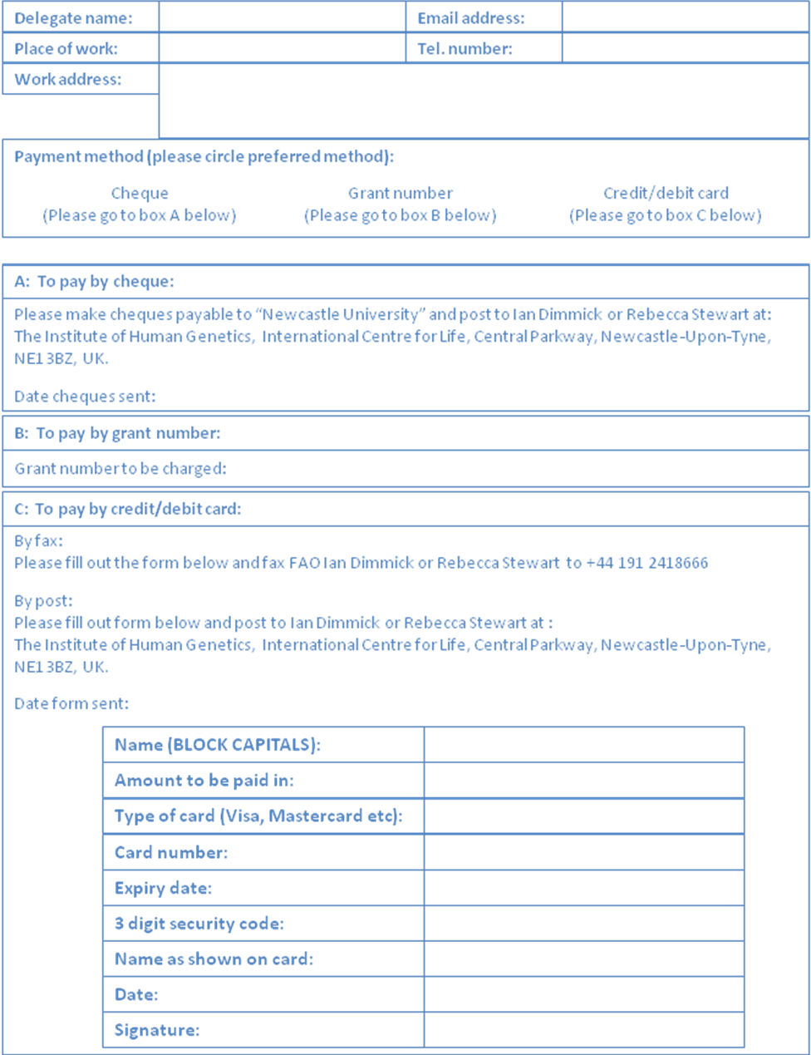
DIRECTIONS

The Assembly Rooms are located within the heart of Newcastle’s city centre.
The main Intercity Central Station is within 250 yards and the local Metro Station is situated directly opposite. Newcastle’s International Airport is only a 15 minute drive away.

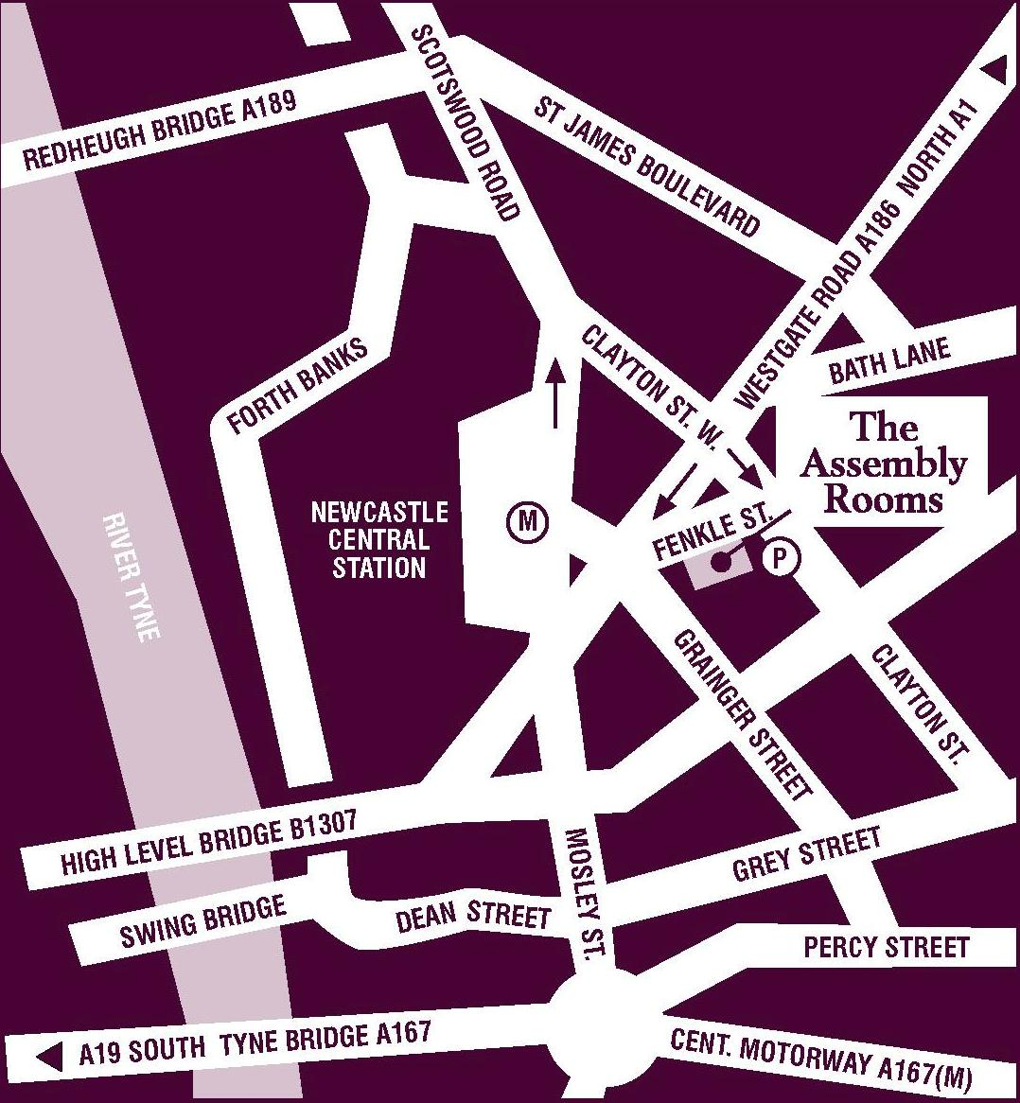
The Assembly Rooms, Fenkle Street, Newcastle-Upon-Tyne, NE1 5XU.
Telephone: 0191 2328695
www.assemblyrooms.co.uk

From the A1 South
Travelling north on the A1(M) you will pass the MOTO Service Station (Washington). Follow the signs for the A1 NEWCASTLE. After approximately 4½ miles take the turn off to the left, signposted A184 Gateshead & Newcastle Centre. Keeping to the right hand lane, cross the River Tyne on the Redheugh Bridge. Stay in the right hand lane and turn right at the third set of lights for City Centre (South A186) at the filter lane at Nexus House. Then turn left at the second set of traffic lights (Burger King is on the corner and the Carling Academy is opposite) then take the first right onto Fenkle Street. The ASSEMBLY ROOMS are approximately 150 yards on the left.

From the A1 North
Follow the A1(M) South and take the road off to the left signposted City Centre (West) A186. Continue to follow the A186 for about 3 miles when you will see a sign for “Fenkle Street” car parking. Shortly after this you will come to a major crossroads with traffic lights (Burger King is on the corner and the Carling Academy is opposite). Turn left, then take the first right onto Fenkle Street. The ASSEMBLY ROOMS are approximately 150 yards on the left.
From the A69
Follow the signs for the A186, go straight across the roundabout at the junction with the A1 and follow the signs for A186 NEWCASTLE until you pass the “Fenkle Street” car parking sign. Then the directions are exactly the same as from the North.

Walking from Central Station
Coming out of the station, cross the main road (Neville Street) at the pedestrian crossing. Turn right and continue walking past the County Thistle Hotel. Turn left at the next corner and walk up Grainger Street past the Rendez Vous (with the torches outside). Cross over at the junction and turn left up Westgate Road. The ASSEMBLY ROOMS are approximately 150 yards on the right.

All delegates for The Practicalities of Flow Cytometry Meeting
are invited to attend:


FlowJo Seminar

With Claudio Vallan (FlowJo, TreeStar Inc.)

Tuesday February 10th, 4:30pm

IHG Seminar room,
Institute of Human Genetics,
International Centre for Life,
Newcastle-Upon-Tyne, NE1 3BZ.

A full introduction to the software will be provided for new users, together with a Q & A session for the more advanced.

This seminar is complimentary for all delegates attending The Practicalities of Flow Cytometry Meeting the following day

If you would like to attend, please email
Ian Dimmick (ian.dimmick@ncl.ac.uk) or
Rebecca Stewart (rebecca.stewart@ncl.ac.uk)
to confirm your place.
The meeting is sponsored by the following companies:

